2019 WIAA STATE TRACK & FIELD CHAMPIONSHIPS Official Relay Team Entry Form

[ ] District Entry on Hytek
[ ] Date____________
[ ] Confirmed WIAA
School- District Classification

Directions:
This form is required at your District/Regional Meet. Enter the names of all relay team members from your school who are participating at your District/Regional Meet. The District/Regional Meet Manager will E-MAIL this form to the appropriate State Track Meet Manager should any teams qualify. Once submitted,
No relay team members may be added. This will ensure that the same team will be entered at the State Meet that entered the District/Regional Meet.

Boys - 4 x 400 Relay Team
Name(First Last) |  | Year
1
2
3
4
5
6
For District Manager use only: Seed #

PLEASE TYPE OR PRINT LEGIBLY
WITH A BLACK PEN
Boys - 4 x 100 Relay Team
Name (First Last) |  | Year
1
2
3
4
5
6
For District Manager use only: Seed #

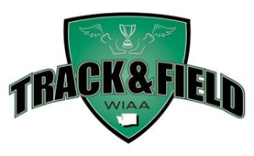

Girls - 4 x 100 Relay Team
Name (First Last ) |  | Year
1
2
3
4
5
6
For District Manager use only: Seed #_____
Girls - 4 x 400 Relay Team
Name (First Last) |  | Year
1
2
3
4
5
6
For District Manager use only: Seed #

Girls - 4 x 200 Relay Team
Name (First Last) |  | Year
1
2
3
4
5
6
For District Manager use only: Seed #

