
2022 SEA-King District 2 3A Track & Field Championships

Event Dates
Prelims: Wednesday, May 18, 2022
Finals: Friday, May 20, 2022

Event Site
Southwest Athletic Complex (SWAC)
27th SW and SW Thistle
Seattle, WA 98126

Contact
Meet Director: Steph Perez, Seattle School District
saperez@seattleschools.org
206.561.5756 (Meet day contact number)
Tournament Bulletin
Games Committee 1
Admission Policies 2
For Spectators 2
For Pass Gate Admissions 2
State Qualifiers 3
Awards 3
Meet Arrangements and Provisions 4
General Information 4
1. Eligibility 4
2. Scoring 4
a. Ties 4
3. Records 4
4. Participant Limitation 4
5. SEA-King Meet Athlete Substitution 4
Meet Procedures 5
1. National Federation Rules 5
2. Meet Referees 5
3. Protest Procedures 5
4. Drawing for Heats - (Non-Timed Final Events) 5
5. Drawing for Lanes (Finals) - (Non-Timed Final Events) 5
6. Running Events - Special Rules 5
7. Field Events - Special Rules 6
8. Athletes’ Uniforms 8
Additional Meet Information 8
Important Notes for Athletes 8

Games Committee
The games committee is responsible for the proper conduct of the 2022 SEA-King District 2 Track and Field Championships. The games committee members will be as follows:
Tara Davis, Seattle School District Athletic Director
Steph Perez, Seattle School District Athletics
Monte Kohler, O’Dea HS Athletic Director
John Hill, Bellevue HS Athletic Director
Advisor: Geof Newing, Meet Referee
The committee will also serve as the Jury of Appeals, following 2022 NFHS Track and Field rules.

Admission Policies

For Spectators
Tickets will only be available digitally via GoFan: https://gofan.co/app/school/WA86276
Prices*
Adults/students without ASB $7.00
Students (with ASB) $5.00
Children K-8 $5.00
Senior Citizens (65+) $5.00
Pre-K N/C
* Does not include service/convenience fees

For Pass Gate Admissions
Competing athletes will be admitted through the main gate area; their names will be checked off on the meet program.

Each participating school will submit a gate pass list to Steph Perez via (saperez@seattleschools.org) by Monday, May 16 prior to arrival at pass gate to cover coaches, relay teams, and volunteers.

Additional admissions will be provided for the following accepted passes: Current Metro and KingCo coaches, Coaches’ Association, SEA-King and WIAA Lifetime

Passes Not Honored: Faculty Credentials

Press must show proper credentials and sign in. School photographers will be admitted without charge at the pass gate with League Identification pass. All photographers are limited to the stands or designated areas. They are not allowed on the infield of the track.

State Qualifiers
The current year’s 3A allocation is top 6 qualifiers. In addition to allocations, contestants in the state qualifying meet who meet or exceed a minimum standard may qualify to participate in the State meet as an extra qualifier; below are the 2022 qualifying standards:
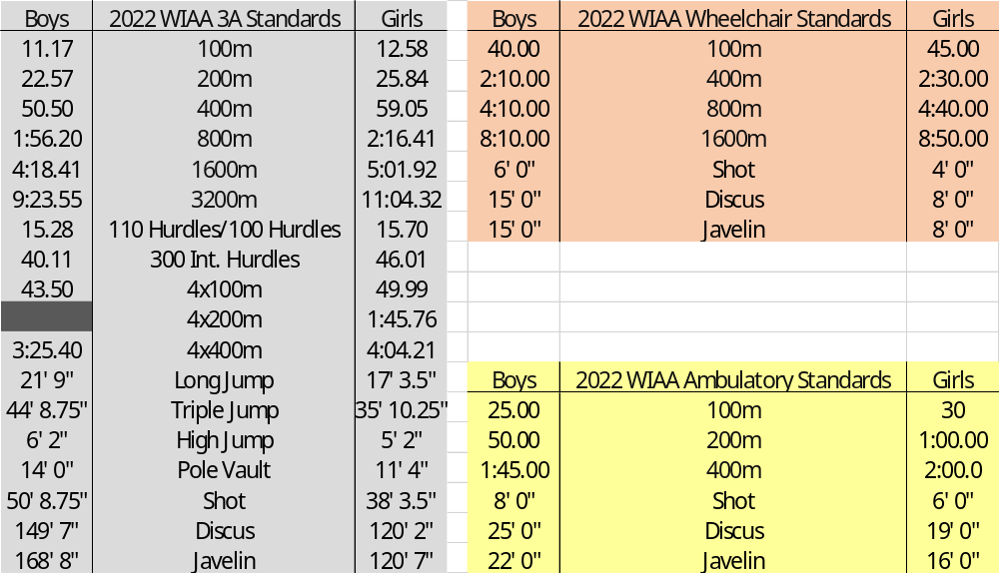

Excerpt from 2022 WIAA Bound for State - Track and Field Regulations:
- In the running events, contestants who have not qualified to state on place must achieve the qualifying mark in the finals.
- In the field events, contestants who have not qualified to state on place can achieve the qualifying mark in both the preliminary trials or the final trials.
- There will be no more than one additional heat for a maximum of 24 competitors in running events. In field events the number of competitors will also be 24 maximum, but no additional flights. (Field event flights will be expanded to a maximum of two flights of 12 competitors.)
- If a situation arises where more than eight running event extra-qualifiers meet the standard, the top eight will be taken in ranked order of district performance.

Awards
Pins – 1st through 3rd places
Ribbons – 4th through 6th places
Trophies –1st place to top team in point standings; only 2 trophies awarded: 3A Girls and 3A Boys

A podium presentation will be awarded to the top 6 finishers directly following each event; this will not include presentation of pins/ribbons.

Awards (pins/ribbons) will be available for pick-up for each school following the conclusion of that day’s final events; any awards not claimed at the conclusion of Friday’s meet will be mailed to the school directly.

Meet Arrangements and Provisions

General Information

Eligibility
All participants must be eligible under WIAA rules and regulations

Scoring
Both individual events and relays following the same scoring system:
Places | 1st | 2nd | 3rd | 4th | 5th | 6th | 7th | 8th
Points | 10 | 8 | 6 | 5 | 4 | 3 | 2 | 1

Ties
The number of tied competitors determines the number of scoring places to be added together; e.g., a tie by two competitors for second place means the scoring points for second and third places shall be added together and divided by two – third place shall remain vacant (NFHS 2-2.4).

Records
Only records established in the preliminaries (if needed) or finals of the SEA-King District 3A Meet shall count as meet records

Participant Limitation
An athlete shall not enter nor compete in more than four events (track and/or field). Any number of these may be relays.

SEA-King Meet Athlete Substitution
Scratches after the Monday, May 16, 2022 12:00 Noon deadline will not be permitted unless illness or injury prevails with the scratched contestant not allowed to compete in any other district competition. Scratches should be submitted to Steph Perez and Ken Emerick. Replacements will be notified, when possible, for a contestant who is scratched due to illness or injury prior to the meet.

Coaches are to submit scratches to BOTH Steph Perez @ saperez@seattleschools.org and Ken Emerick @ ken123e@aol.com by 12:00 Noon on Monday, May 16, 2022. Coaches scratching athletes at this point should contact the school who has the alternate and notify them of the scratch as well.

Following this deadline, any and all scratches at this point will be a “scratch one – scratch all” unless there is a medical note authorizing something different. Medical notes must be submitted to Steph Perez. Scratch replacement procedures following the deadline are as follows:

3A– First replacement will go to the league from which the athlete scratched. If no athlete from that league is available, it will defer to the other league

Meet Procedures

National Federation Rules
National Federation Rules will govern the meet; Below are significant 2022 NFHS Track Points of Emphasis or Rule Changes:
- Adjust exchange zone rules to incorporate the acceleration zone for relays with legs of 200 meters of less
- Permit use of electronic devices in unrestricted areas and coaches’ boxes, provided it does not interfere with meet progress
- Provide reasonable accommodations to individual participants with disabilities and/or special needs, as well as those individuals with unique and extenuating circumstances, provided these accommodations do not fundamentally alter the sport, heighten risk, or place opponents at advantages

Meet Referees
Any concerns that arise during the meet will be the responsibility of that event’s official

Protest Procedures
The head coach first protests to the referee; their decision is appealable. A written appeal [Protest Form] shall be submitted by the coach with their signature to the meet manager within one-half hour after the results have been announced by the P.A. or made official. The Games Committee will serve as the Jury of Appeals. They will convene to review the protest; their decision will be final.

Drawing for Heats - (Non-Timed Final Events)
1st and 2nd for the League meet will be placed into the preferred lanes for that race accordingly. Heats will be in fields of 6 and 6. Once those runners are seeded, all subsequent placements will be based on next fastest times.
The advancement formula will be the winners of each heat plus next 6 fastest times.

Drawing for Lanes (Finals) - (Non-Timed Final Events)
In accordance with the WIAA State Qualifying Syllabus, the fastest 2 times in the prelims. will be placed in lanes 4 and 5 by chance, the next two fastest in lanes 3 and 6, and so forth.

Running Events - Special Rules
- Relay runners must not mark track with spikes. Tape is acceptable but must be removed immediately after the race. Any runner scratching the track for take-off marks will be disqualified.
- Starting blocks will be provided. Individuals may use their own blocks only if approved by the Meet Director and there is no delay in starting the race while waiting for the blocks.
- The 800m race will be seeded via an alley-format as follows:
        - Lanes 1 & 2: 7th-9th Times
        - Lanes 3 & 4: 1st-3rd Times
        - Lanes 5 & 6: 4th-6th Times
        - Lanes 7 & 8: 10th-12th Times
- A three-turn stagger will be used in the 4 x 200 relay and the 4 x 400 relays.
Note: This allows for use of acceleration zones in all three exchanges in the 4 x 200 relay. The fourth runner of the 4 x 200 relay may cut. In the 4 x 400 relay, the second runner cuts on the break line in the backstretch.

Field Events - Special Rules
- Each 3A competitor shall be allowed three preliminary trial attempts in flights of 12 persons. In the finals, each qualifier is allowed three additional trials.
- Contestants in field events will be permitted 1 minute to jump or throw after being notified by the official. Failure to comply will be recorded as a try.
  - Pole Vault – This event will start at the height of the best jump of the last competitor in the League meets, with 6" rises to 13' and 3" rises thereafter. Competitors must have their coach’s certification. (See Pole Vaulter Weight Verification Form)
  - High Jump - This event will start at the height of the best jump of the last competitor from the League meets, with 2" rises to 6' for boys and 5' for girls and 1" rises thereafter.
  - Javelin - Each thrower will provide their own implement for the event. Only approved javelins will be used in the District Meet. Only rubber-tipped javelins will be allowed in any competition. No use of other competitor’s javelin without permission.
  - Shot Put - Each competitor will provide their own implement for the event. The format will be a one-one-one throw sequence by flights. Warming up must be under the supervision of a meet official.
  - Discus - Each competitor will provide their own implement for the event. The format will be a one-one-one throw sequence by flights.
- Implement Inspection - All throwing implements must be certified by the Implement Official before warm-ups begin, regardless of the implement(s) are used for either warm-ups or competition.
Implements inspection will be performed in a designated space, starting one hour prior to warm-ups. Schools are encouraged to mark their implements in advance to reduce the check-in line (paint pen works best for shots, Sharpie is adequate for discus and javelins). Javelin throwers are encouraged to clean the dirt/mud off their javelin tips in advance.
The Implement Official will weigh, measure, and inspect surfaces and/or grips of all implements. Only legal implements, as determined by the Implement Inspector, shall be allowed in warm-ups and competition.
Certified implements will be marked and delivered to the throwing areas in time for warm-ups. Disqualified implements will be impounded and held in the inspection area; they may be picked up after the end of the competition.
Shots certified for competition will be placed in a pool and may be thrown by any competitor. Discus and javelins certified for competition will not be shared without permission from the school to which they belong. Only rubber-tipped javelins will be used. All implements will remain at the venue until competition is completed.
There will be no throws warm-ups outside of the scheduled event warm-ups that are supervised by the head judge.
Special Instructions - Preliminaries and Finals
  - In preliminaries, contestants in the Shot Put, Discus, Javelin, Long Jump and Triple Jump will compete in groups of twelve as per special rules. Each member of a group will complete their preliminary throws or jumps before the next flight begins.
  - Only top NINE competitors, plus any ties for ninth place, shall qualify for the finals in the Shot Put, Long Jump, Triple Jump, Discus, and Javelin. The order of competition in the finals shall be in the reverse order of the best performances in the preliminaries.
  - The top NINE contestants in each event, plus any ties for ninth place, will be allowed three additional tries in the finals. The order of competition in the finals will be in the reverse of the best performance in the preliminaries.
- Breaking Ties (NFHS 6-4.2)
  - A tie for the last qualifying spot to the state meet must be broken (WIAA Bound for State - Track and Field Regulations)
  - For places determined by distance:
    - If the distance resulting from the best performance of competitors is identical, the higher place is awarded to the typing competitor whose second-best performance is better than either the prelims or finals.
    - If the tie remains after the above followed, the higher place is awarded to the tied competitor whose third-best performance is better than the third-best performance of any tied competitor, etc.
  - For places determined by height:
    - The competitor with the fewest number of trials for the height at which the tie occurs, i.e., the last height successfully cleared, shall be awarded the higher place
    - If the tie remains, the competitor with the fewest total number of unsuccessful trials throughout the competition, up to and including the height last cleared, shall be awarded the higher place.
    - Passed trials shall not count as misses.
    - If the tie remains after the above followed, and:
      - It concerns first place, the competitors tying shall make one more attempt at the height which they failed. If no decision is reached, the bar shall be lowered in increments of 1 inch (2 cm) in high jump and 3 inches (7 cm) in pole vault. If two or more of the tying contestants cleared the height, the bar shall be raised by intervals of 1 inch (2 cm) in high jump and 3 inches (7 cm) in pole vault. Each competitor shall attempt one trial at each height until a winner is determined.
        - If the height which the tied competitors last jumped is not the same, because of a passed height by one or more of the remaining competitors, the bar shall be lowered to the lowest height last attempted by any of the remaining competitors to being the jump-off.
      - The tie concerns any place other than first, the competitors shall be awarded the same place.

Athletes’ Uniforms
      - Contestants shall wear only the legal uniforms issued by the school (NFHS 4-3)
      - The referee shall “prior to the meet… address [via a coaches’ meeting] the following with all head coaches… [confirming] that all of the team’s competitors are properly equipped (uniform and equipment) in compliance with these rules” (NFHS 3-4.8b). A school shall inquire/resolve any uniform questions prior to the meet.
      - All jersey are required to be tucked into an athlete’s shorts to facilitate automatic timing. Hip numbers will be issued for all running events.

Additional Meet Information
- Automatic timing will be used for all races.
- Certified athletic trainers are provided through Seattle Children’s Hospital. They are available onsite for medical personnel and emergency purposes.
- The meet will have designated marshals who have been instructed to keep the facility clear of those not competing or officiating.
- The running warm-up area is in the middle of the football field. Athletes warming up should stay in the white lined area.
- At all times, coaches and managers are to remain in the stands. It will not be necessary for team managers to be on the field at any time.
- Athletes are to remain in the stand when not competing. Coaches, please remind student-athletes to return to the stands after completing an event to ensure enough warm-up space available for athletes.
- Coaches, managers, and statisticians will not be allowed in the finish area. No times are to be given at the finish line; results are announced via display boards, live results, and P.A. system announcements.
    - Statisticians and others will not be permitted in the press box. Live results will be posted on https://live.pntfo.com/meets/13348 and official meet results will be posted on athletic.net
- Only the referee can disqualify a contestant or relay team after complete details of the infraction have been brought to their attention.

Important Notes for Athletes
- Student-athletes should arrive dressed for competition. Dressing room space will not be available.
- Each team is responsible for their own valuables.
- Reminder that spikes are not to exceed 1/4" (3/16" preferred). Contestants using longer spikes will not be permitted to participate.
- It is the responsibility of the student and their coach/family to plan around school/IB/AP testing schedules, so these assessments do not impact their ability to participate in any event.
Important Notes for Coaches
- Coaches will pick up meet information during the coaches’ meeting before the meet
- With regard to scratches, schools are reminded of WIAA Rule 22.2.5. In summation, by entering into an event, schools are certifying their athlete intends to compete through the state meet.
- If an athletic has been disqualified from the meet because they are not competing through the state meet, points will be removed, if any, from any previous events the athlete has participated and will be scratched from any events entered. The alternate will be placed into the event vacated.
- Each school will be contacted prior to the meet regarding their volunteer assignments. In return, schools will provide the names of their volunteers to the tournament manager as part of the pass list. If assigned volunteers do not show up, coaches are expected to replace these volunteers.
    - Relay Exchange Zone Judges – Schools assigned as relay judges should be familiar with course markings of the exchange zone before the event to ensure accurate officiating.
- Coaches and managers must remain in the stands, outside the track, or in designated field event viewing areas.
    - Coaches and spectators who wish to observe field events CANNOT cross through the stadium field

