[](http://www.wiaadistrict1.com/) [](http://www.wiaadistrict2.com/) 2A PLAYOFF AGREEMENT DEVELOPMENT

MEETING: Bob’s Burger and Brew in Tulalip TIME: 9 am

DATE: June 3, 2016

ATTENDANCE: ANACORTES, ARCHBISHOP, BELLINGHAM, BLAINE, BURLINGTON-EDISON, CEDARCREST, GRANITE FALLS, LAKEWOOD, LIBERTY, LYNDEN, SAMMAMISH, SEDRO-WOOLLEY, SEHOME, TERRACE, JIM PICCOLO, TOM DOYLE

MINUTES

1. Review possible Allocation Numbers:

A. 2A District to State from the numbers it looks like Combined District 1/2 will get 4 berths in Year One & 3 berths in Year 2. Allocations were confirmed by WIAA.

B. Conferences to Districts

2. Guiding Principles when negotiating:

A. Four Conferences coming together for post-season. Thinking outside the box.

B. Schools playing in 3A conference needs to be considered; League Records need to be considered.

C. Fairness to have games at KingCo/WESCO sites.

D. Opportunity for many teams.

3. Tennis Agreement:

YEAR ONE SITE(S): Districts Boys @ Sehome/WWU District Girls @ Sehome/WWU

DATES: District Boys October 7, 8, 10, 11, 2016 DATES: Sub-District Girls May 5,6,8,9, 2017

DATES: District Girls May 13, 14, 16, 17, 2017

YEAR TWO SITE(s): Districts Boys @ Granite Falls District Girls @ Granite Falls

DATES: District Boys October 6, 7, 9, 10, 2017 DATES: Sub-District Girls May 4,5,7,8, 2018

DATES: District Girls May 12, 13, 15, 16, 2018

NUMBER OF TEAMS:

Girls Teams- 8 NWC 2 CC 1 WESCO 2 KingCo

Boys Teams- 6 NWC 1 maybe 2 CC 1 WESCO 2 KingCo

* Colin Cushman, Sehome AD will handle seeding and placement.
* Girls will have a Sub-District South and Sub-District North to Qualify for Districts.
* Boys will have a Sub-District South and Sub-District North, If Granite Falls has a team. If not all 10 schools will go directly to Districts.

4. Track Agreement:

YEAR ONE SITE(S): Districts @ Civic Stadium Bellingham DATES: May 17, 19, 2017

YEAR TWO SITE(s): Districts @ Cedarcrest DATES: May 16, 18, 2018

YEAR ONE SITE(S): Sub-Districts North @ Civic Stadium Bellingham DATES: May 10, 12, 2017

Sub-Districts South @ Cedarcrest DATES: May 10, 12, 2017

YEAR TWO SITE(s): Sub-Districts North @ Civic Stadium Bellingham DATES: May 9, 11, 2018

Sub-Districts South @ Edmonds Stadium DATES: May 9, 11, 2018

NUMBER OF TEAMS: 8 NWC 3 CC 1 WESCO 2 KingCo

* Each school will get an entry and then next two best marks/times from the previous week’s qualifying meets. Will also back fill any spots not filled by a conference.

* LANED RACE PRELIMS YEAR ONE/TWO:  8 Northwest, 3 Cascade, 2 KINGCO, 1 WESCO plus the next best two (2) qualifying marks from the previous week’s qualifying meets.

•  Times/distances used to seed the District Meet will be determined using times from previous weeks qualifying meet.

            •  Additional heats will be run if 17 or more athletes qualify for a preliminary race due to ties.

         • Heat assignments will be based upon time at the previous week’s conference meets and seeded using Hy-Tek Meet Manager Software.

            •  The State Meet conversion formula will be used in the event hand-held times are used.

* 1600 AND 3200 YEAR ONE/TWO:   8 Northwest, 3 Cascade, 2 KINGCO, 1 WESCO plus the next best two (2) qualifying marks from the previous week’s qualifying meets.
* FIELD EVENT PRELIMS YEAR ONE/TWO:  8 Northwest, 3 Cascade, 2 KINGCO, 1 WESCO plus the next best two (2) qualifying marks from the previous week’s qualifying meets.
* RELAYS:   All schools are allowed one entry.  A preliminary heat will be held if each team enters a relay. If eight or less schools enter a relay then each team will be entered into a final heat based upon time posted at the previous week’s Conference Meets. Hy-Tek Meet Manager Software will be used to determine heat placement.
* All athletes and relay teams that qualify on Wednesday for the Friday finals will advance to the District meet regardless of a disqualification for a performance/competition related violation that occurs in the Friday finals. ALL other non-performance based disqualifications will result in non-advancement (ex: sportsmanship, uniform, and other non-performance related DQ’s). Any athlete or relay team disqualified for a performance/competition related violation occurring in the Friday finals will receive the last seed from its sub qualifying meet.
* ADD-INS are not allowed.

5. Cross Country Agreement:

YEAR ONE SITE(S): Districts @ South Whidbey DATES: October 29, 2016

YEAR TWO SITE(s): Districts @ South Whidbey DATES: October 28, 2017

NUMBER OF TEAMS: 8 NWC 3 CC 1 WESCO 2 KingCo

* Each School enters a team.

6. Golf Agreement:

YEAR ONE SITE(S): Districts Boys @ Snohomish GCC District Girls @ Skagit GCC

DATES: May 15 & 16, 2017

YEAR TWO SITE(s): Districts Boys @ Skagit GCC District Girls @ Snohomish GCC

DATES: May 14 & 15, 2018

* Reduce the field to 70% of District One and Two Golfers.
* Any one school will only be allowed to submit up to 6 qualifying golfers for day one entry.

i.e. 14 2A District One and Two schools X 6 golfers per school = 84 Total Golfers

84 Golfers X 70% =58.8 Round that to a total of 59 Golfers for the field into Districts.

NWC 57.1%, which would be 34 golfers into Districts.

CC 21.4%, which would be 13 golfers into Districts.

KingCo 14.3%, which would be 8 golfers into Districts.

WESCO .07%, which would be 4 golfers into Districts. Note: If Terrace 5th and 6th Place golfers meets or exceeds the cut score average of all 59 qualifying golfers, they will have an entry into the district tournament.

* Day Two Qualifying: The field will be cut in half taking the top 50% of the field from day one plus any ties OR reduced to the doubled the amount of allocations to state, whichever is greater.
* Coaching Rule: 1-2 golfers: 1 Coach Pass; 3+ Golfers: 2 Coach Passes. Such a person(s) shall be identified to the rules committee before any team member begins play. They may give advice to their players any where on the course. They may not read greens and must stay off the greens. The coach(s) can not cause a player to unduly delay play. Coaches will not give advice or rulings to other schools golfers. They can call the club house for a ruling for the individual, if needed.
* A cut score will be in place for both girls and boys to make post-season play.

7. Wrestling Agreement:

YEAR ONE SITE(S): Sub-Regional Boys North @ Sedro-Woolley

Sub-Regional Girls @ Burlington-Edison

Sub-Regional Boys South @ Liberty

YEAR TWO SITE(s): Sub-Regional Boys North @ Sedro-Woolley

Sub-Regional Girls @ Bellingham

Sub-Regional Boys South @ Edmonds (Terrace)

* Predicting Entry into Regionals for Boys in Year One: 5 North and 3 South

Year Two: 4 North and 4 South

* Girls Sub-Regionals will be determined by WIAA

8. Swimming/Dive Agreement:

* Swimmers will qualify based upon District qualifying standards. Each school gets 1 minimum entry.

YEAR ONE SITE(S): Fidalgo Pool (Anacortes)

YEAR TWO SITE(s): Fidalgo Pool (Anacortes)

9. Volleyball, Basketball, Softball, Baseball, Soccer Agreement:

* Bracket: 12 Team Bracket

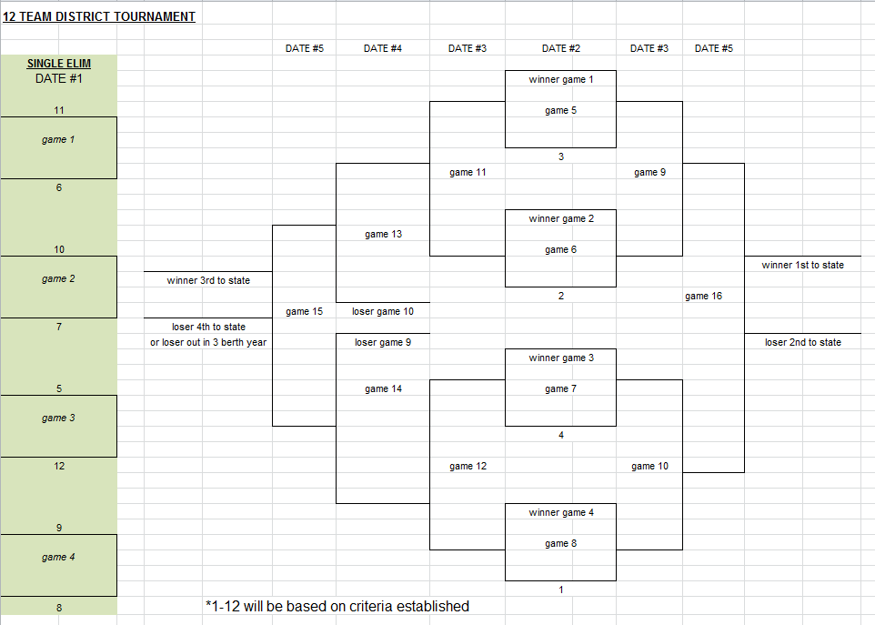

* Seeding will be determined by criteria established using a mathematical weighting system. We established a committee to determine weight factors for schools beating schools in a higher classification.

Volleyball:

* Will play games 1-4 at the four top seed sites on Tuesday, then games 5-12 will be played on Thursday of the same week. Sites for games 13-16 on Saturday games will

YEAR ONE SITE(S): Mountlake Terrace/Lynden & MLT DATES: Nov. 1, 3, 5

YEAR TWO SITE(s): Sammamish/Lynden & Lynden DATES: Oct. 31. Nov. 2, 4

* Number one RPI seed gets to be the host site in for games 7, 8, 10, 12.

Basketball:

* Will play games 1-4 at the higher seed site on Wednesday Girls/Thursday Boys, Games 5-8 will continue at the higher seed site, then remaining games 9-16 will be played:

YEAR ONE SITE(S): Mount Vernon High School

YEAR TWO SITE(s): Mount Vernon High School

Softball:

* Will play games 1-4 on Saturday, games 5-12 on Wednesday, then remaining games 13-16 will be played on the Friday of the same week. Sites for Wednesday and Friday games will be:

YEAR ONE SITE(S): Janicki (Sedro-Woolley)

YEAR TWO SITE(s): Janicki (Sedro-Woolley)

* No admission will be charged on Saturday games 1-4.

Baseball:

* Will play games 1-8 on Saturday, games 9-12 on Tuesday, then remaining games 13-16 will be played on the Saturday of the same week. Sites for baseball district will be:

YEAR ONE SITE(S): Daniel and Volunteer Fields (Anacortes) DATES: April 29, May 6, 9, 13

YEAR TWO SITE(s): Daniel and Volunteer Fields (Anacortes) Dates: April 28, May 5, 8, 12

* No admission will be charged on Monday games 1-4.

Soccer:

* Will play games 1-4 on Tuesday, games 5-8 will be played on Saturday, then games 9-12 on Tuesday, and games 13-14 on Thursday, with the remaining games 15-16 will be played on the Saturday of the same week. Sites for soccer district games 13-16 will be:

*YEAR ONE SITE(S): Districts Boys @ Sedro-Woolley DATES: May 4, 6, 9, 13

District Girls @ Liberty DATES: Nov. 3, 5, 8, 12

YEAR TWO SITE(s): Districts Boys @ Liberty DATES: May 3, 5, 8, 10, 12

District Girls @ Sedro-Woolley DATES: Nov. 2, 4, 7, 9, 11

* ***NOTE: If for games 13-16 two teams from the North or Two teams from the South face each other, then teams will be allowed to play in the respective neutral locations as follows:***

***YEAR ONE SITE(S): Districts Boys @ Edmonds Stadium District Girls @ Sedro-Woolley***

***YEAR TWO SITE(s): Districts Boys @ Sedro-Woolley District Girls @ Edmonds Stadium***

NOTE: *In a 4 berth year (year one), game 15 will not be played. The RPI will determine the number 3 and number 4 seeds to State First Round. In a 3 berth year, game 15 will be played as it will eliminate a team.

Football Agreement:

* The same seeding criteria will be determined by criteria established using a mathematical weighting system to be consistent with Team Sports (VB, BB, SB, Baseball, & Soc) Criteria to determine the order of south schools in football. Again, we established a committee to determine weight factors for schools beating schools in different classifications.
* It was discussed and agreed that the NWC (Football only) will be allowed to finish in a 4 and 3 berth years in order of finish with in the conference. Concerns and discussion around RPI could, even though unlikely, flip order of finish when two teams with similar record and no head to head was considered.
* Bottom Team is the home team in the bracket. North will throw #4 team into the South in the 3 berth year and will get seeded if they qualify by the RPI to get the position.
* The Rank Order of finish from Week 10 into the first round state playoffs will be based on the seeds meaning seed #1, then seed #2, then seed #3, then seed #4. If two seeds are the same i.e. North #1 and South #1, or North #2 and South #2, or North #3 and South #3, or North #4 and South #4 both make it in, then, the RPI will determine the higher seed into first round state playoffs.



Agreement for the next two year cycle and agree that any changes need to come back to the committee for review.

__________________________________________ ______________________

Northwest Conference President-Donald Beazizo Date

__________________________________________ ______________________

Cascade Conference President-Jason Frederick Date

__________________________________________ ______________________

WESCO Representative-Julie Stroncek Date

__________________________________________ ______________________

KingCo Representative- Date