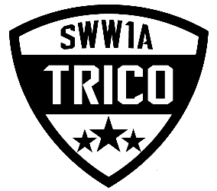

Boys Soccer Memo
To: Trico league boys’ soccer coaches and players

From: The Trico league Athletic Directors

RE: Unsportsmanlike conduct

Dear, Coaches and players competing in the Trico league we have had numerous complaints from official’s, fans and coaches regarding the unsportsmanlike behavior from coaches and players throughout last season. The Trico league AD’s have unanimously voted to add an additional (1) game suspension to any coach or athlete that receives a suspension throughout the 2019 season. This would include rule 38.3.3 in the WIAA handbook any player that is issued a second yellow card caution will be disqualified from participating for the remainder of the match. A player would sit out the rest of that contest and the following contest.

Sincerely,
Neil Williamson

Trico League President
Cc
La Center-Matt Cooke
Seton Catholic-Phil Kent
Columbia WS-Howard Kreps
Kings Way-Ted Buck
Toledo-Grady Fallen
Stevenson-Chuck Strong

