2023
Please distribute to:
__Coach
__Athletic Director
__Activity Director
__Principal/Administration
__Cheerleader Advisor
__Band Director
__Dance/Drill Advisor
WCD III/SWD IV/SKD II
BASKETBALL TOURNAMENT

February 10th-18th

Sites Site Manager* Phone E-mail

HS (of higher seed in Rnd1) Home A.D.
AUBURN (3A) Jon Price 253-951-5056 jprice@auburn.wednet.edu
MT TAHOMA (1A) Rhonda Stinson 253-571-3840 rstinso@tacoma.k12.wa.us
CURTIS (4A) Suzanne Vick 253-380-6531 svick@upsd83.org
Shelly Nygaard 253-566-5718 snygaard@upsd83.org
MOUNT TAHOMA (2A) Rhonda Stinson 253-571-3840 rstinso@tacoma.k12.wa.us
NORTH MASON (2A) Raymond Bonnell 360-277-2165 rbonnell@northmasonschools.org
HIGHLINE HS (2A) Lori Box 206-631-6634 lori.jensenbox@highlineschools.org
* Site managers reserve the right to make decisions regarding game management operations.
TICKET PRICES: GoFan Digital Ticketing is the only purchase method. No cash sales at the venues will be available. First round games may have seating limitations. Advanced sales through GoFan is encouraged. District-2 hosted games link to GoFan tickets for semi-final 2A games will be posted by D-2
District Director.

Link to GoFan WCD ticket purchasing:

https://gofan.co/app/school/WA71989

ADULTS: $8.00 & students without ASB Card

STUDENTS: $5.00 with ASB Card

SENIOR CITIZENS: $5.00 (62+)

MILITARY: $4.00

ELEMENTARY $4.00

FACILITY OPENING: The facility will open one hour before the beginning of the first game each day.

CHECKOUTS: Adult checkouts OK with hands stamped for re-admittance.
No student checkouts.

SEATING: Signs may be posted above bleacher areas where student sections for each school will be located for their game. These areas may be cleared after each contest, to allow the fans of the teams in the next contest to have seats.
.
ALCOHOLIC BEVERAGES: Not allowed on campus.

SMOKING: No smoking, use of tobacco products, including vaping, will be allowed on school grounds (inside or outside of venues).

GAME FLOOR: Only participating players are allowed on the playing floor.

VIDEO: There may be a designated area for team video. All other videoing from spectator stands must not hinder spectator viewing. Power may not be available. Extension cords will not be provided.

PASSES: Only WCD Authorized passes, WCD Sponsor passes, WSCA (Coaches Association) passes, and WSSAAA (A.D. Association) passes will be honored!!! School District, League, WIAA, WOA, etc. will not be accepted.

Supervisor: Four (4) per school. Supervisor Badges will be provided at pass gate. (Supervisors are required to wear badges so they are visible to students, staff etc.) Each school will also identify a Head Supervisor who will wear said badge and check in with game manager. At the end of game, return badge at gate.

Chaperone: Up to five (5) will be available at $10.00 apiece. These passes will be signed for on the “Additional Supervisor/Chaperone Pass” form at each site and a hand stamp will be made for the purchaser.

Pass Gate: Superintendent and School Board, Principals and Assistant Principals will be identified on a Pass List at venue pass gate and must sign in. In addition, one (1) School Photographer and one (1) School Press will be admitted with a letter on dated school letterhead signed by Principal or Athletic Director. Picture identification will be required by all before admittance. All others will be admitted as either Supervisor or Chaperone.

UPDATE: Team: Twelve (12) players may suit up. Twenty (20) (+1) licensed medical provider/trainer is the total allowed on any bench! (Twelve (12) players and eight (8)) staff including coaches, school trainers, video operator, etc). +1 licensed trainer/medical provider (with current ID) can also sit on the bench. Admittance is through the pass gate. Teams (coaches/players) are admitted free after checking in at Pass Gate to attend games within their classification.

Scouts: Scouts (limit 3) must contact site manager 24 hours in advance to arrange for a pass(es). College scouts are not allowed free admission.

Officials: Only officials working games that night, plus one, are allowed free admission. Local associations may send an observer, but they must display an observer pass at the pass gate. Those accompanying must pay. RTO officials must present “State Observer Pass” for free admittance.

SIGNS: The official school banner is the only sign permitted. This includes hand held signs.

CONFETTI: The dispersal of confetti is NOT allowed. Schools that violate this rule will be subject to paying the additional cleanup expenses.

BALLOONS/SELFIE STICKS: NOT allowed.

NOISEMAKERS: Artificial noisemakers of any kind are prohibited and may be confiscated by the management staff.

MEGAPHONES: Megaphones are to be used only by the cheer staff. Pounding megaphones on the floor as a noisemaker is prohibited.

CROWD CONTROL: Participating schools will be responsible for supervising their respective student bodies. School supervisors are expected to wear
badges and sit in their student section during the game.

CONDUCT: Face or body paint is unacceptable (face decal OK). Shirts are required. Note following “Just Play Fair!” behavior expectations:
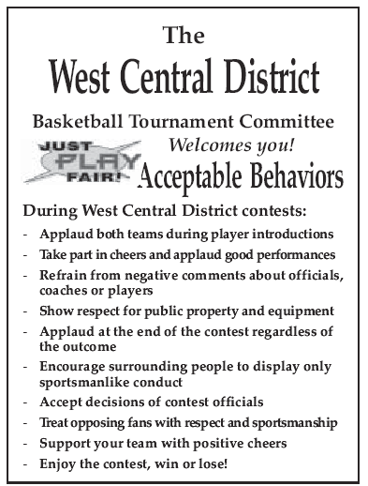
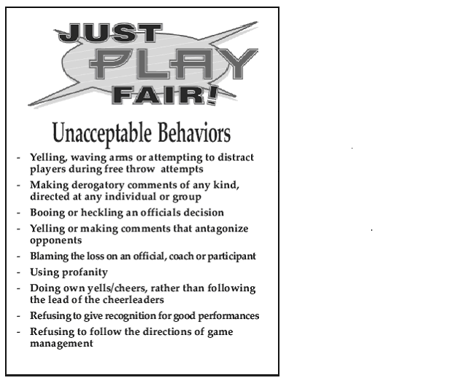

FAN SEATING: Each school will have designated seating. Sitting in the aisles will not be permitted. Depending upon venue, food or drink may be prohibited in gym.

CHEERLEADERS/ DANCE/DRILL Cheerleaders/Dance/Drill members in uniform will be admitted free with their advisor at the pass gate. Cheerleaders are to cheer from the areas designated by game management. Drill teams and/or cheerleaders may perform on the floor at halftime. Performances require 24 hours prior notification to the tournament manager. If both schools wish to perform, the time will be shared equally.

BANDS Band performers in uniform will be admitted at the pass gate with their director and/or advisor present and checking them in. Advisors who have programs with more than 30 members must contact and request at least 24 hours in advance of game for additional band seating. The site game manager has the right to determine seating availability. Verify with the game manager for band location. ALL equipment must be kept in the stands! No aisles or stairways can be blocked. If your band needs electric power for some instruments, you will need to provide your own extension cords and realize that the use of electricity may not be possible. Drum set platforms will not be provided. Bands are to play only before and after the game, during timeouts, and between periods. Amplifier volume must be controlled. The tournament manager/staff is empowered to control amplifier volume. Instruments, including drums, are not to be used as noisemakers. Bands are to promote good sportsmanship for all players, spectators, and officials, and avoid inciting negative attitudes towards officials and opponents. The designated home school’s band will play the national anthem.

HOME TEAM: In the WCD draw, the higher seed is the home team, throughout the tournament. Home teams wear white uniforms.

GAME BALL: The home team is to furnish the game ball. WIAA-designated Baden ball is the preferred choice, but not required.

SCOREKEEPER: The WCD/Site Manager will designate the Official scorekeeper.

PRE-GAME: Introductions and the National Anthem will start five minutes prior to the first session game. The home team band will have the first option to play the National Anthem. For all other games the introductions will begin five minutes before the start of the game.

VALUABLES: Each team is responsible for its own valuables. Lockers may not be available.

TOWELS: Each team is responsible for its own towels.

TRAINER: An athletic trainer will be provided by the school or WCDIII. An AED will be available. Each team is responsible for its own tape and other supplies.

LOCKER ROOMS: Assignment of locker rooms will be made on the day of the game at venue. Some flexibility may be needed at site regarding entrance to rooms.

PRACTICE: No practice at the game site prior to and during the tournament, unless
it is a normal practice for the home site school and ends an hour and a half prior to the first posted game time.

PRE-GAME WARM -UP: Maximum of twenty (20) minutes and a minimum of fifteen (15) minutes, including the first game of each session. Introductions will be made following the warm-up period at five (5) minutes before start of game.

GAME TIME: As posted on brackets. In first round 7:00, unless otherwise noted.

TEAM BENCHES: Site manager will designate home and visitor benches. A limit of 15 chairs will be arranged for teams; a 16th chair may be added for licensed trainer/medical professional, with current ID.

AWARDS: Plaques: West Central District will provide 1st and 2nd place plaques.
Certificates: Participation certificates will be provided to WCDIII member schools prior to the tournament.

Sportsmanship pins: will be awarded to a player, fan or other person exhibiting outstanding sportsmanship, for each team, at the conclusion of the contest.

RADIO/TV BROADCASTING: Broadcasters from radio, television, web streams or other similar media organizations are required to complete the on-line application form posted on the WCDIII website (under “Forms” and “Broadcasting Forms”). Once approved by the WCDIII Office, broadcasters will need to contact the respective site manager for arrangements. PRIVATE, SCOUTING or PARENT VIDEO/BROADCASTING with i-pads, phones, etc. will not be allowed on the floor, or be given free admission.

POSTPONEMENT/CHANGE In the event of an emergency affecting tournament/playoff sites, dates or times, the W.C.D. III Executive Board Basketball Chairperson, the Tourney Manager and the WCDIII Director will make the necessary adjustments. The Tournament Staff reserves the right to make change of sites, times of games, bench location and other decisions as deemed necessary . Game sites and/or times may be changed to accommodate teams geographically. Tournament sites may also be the home team site for team(s) in the tournament.

1/27/23

